**LIT ASSIGNMENT - DAY 15**

**Batch: SAP ABAP ON HANA**

**EMP ID:46255236**

Assignment 1 – Create a Simple program to fetch data and display ALV using Std. SAP class-methods.

**Scenario** –

* Create a Custom program using ECLIPSE. Select data from table SNWD_PD.
* The output should consist three columns – Category, Max price and Average price.
* The data should consist of all categories from SNWD_PD, with maximum price for each category and average price for each category.
* There should be only 1 select statement used to achieve this using In-line Declaration, CASE, Aggregate, HAVING and GROUP BY clauses as needed.
* Selection screen can contain CATEGORY
* Output should be in ALV Grid format.

**Tables involved** – SNWD_PD / Columns – CATEGORY & PRICE

**REPORT:**

REPORT z5236_alv_ida.

TABLES:SNWD_PD.

DATA: it_fieldcat TYPE slis_t_fieldcat_alv,

wa_fieldcat TYPE slis_fieldcat_alv.

SELECT CATEGORY,

MAX( PRICE ) AS MAX_PRICE,

AVG( PRICE ) AS AVG_PRICE,

CASE

WHEN length( category ) < 6 then 'LOW LENGTH CATEGORY'

WHEN length( category ) > 6 then 'LOW LENGTH CATEGORY'

END as group

FROM SNWD_PD AS A GROUP BY CATEGORY having length( category ) > 4 INTO TABLE @DATA(IT_OUT).

wa_fieldcat-fieldname = 'CATEGORY'.

wa_fieldcat-seltext_m = 'CATEGORY'.

APPEND wa_fieldcat TO it_fieldcat.

wa_fieldcat-fieldname = 'MAX_PRICE'.

wa_fieldcat-seltext_m = 'MAX_PRICE'.

APPEND wa_fieldcat TO it_fieldcat.

wa_fieldcat-fieldname = 'AVG_PRICE'.

wa_fieldcat-seltext_m = 'AVG_PRICE'.

APPEND wa_fieldcat TO it_fieldcat.

wa_fieldcat-fieldname = 'GROUP'.

wa_fieldcat-seltext_m = 'CAT_GROUP'.

APPEND wa_fieldcat TO it_fieldcat.

CALL FUNCTION 'REUSE_ALV_GRID_DISPLAY'

EXPORTING

it_fieldcat = it_fieldcat

TABLES

t_outtab = IT_OUT

EXCEPTIONS

program_error = 1

OTHERS = 2.

OUTPUT:

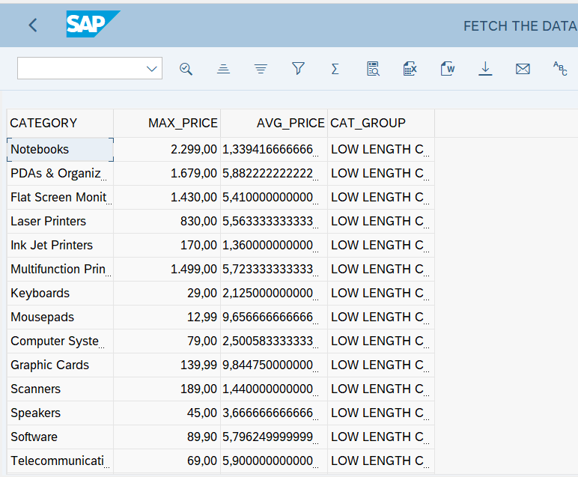

Assignment 2 – ALV with IDA

**Scenario** –

* Create one CDS view by selecting fields VBELN,POSNR, VKORG, MATNR, MENGE from VBAK and VBAP table
* Perform below operations using IDA framework

1. Create select-options based on MATNR for selection screen
2. Fetch records from CDS view in ABAP program
3. Pass user input (select-option entries) to filter record accordingly
4. Hide POSNR field from display
5. Change label of VBELN as SOrder, VKORG as SOrganization, and MENGE as TotalQuantity
6. Disable standard function SORT for MATNR field
7. Hide standard toolbar FILTER
8. Set title as “ALV report with IDA, CDS consumption”
9. Enable ZEBRA pattern
10. Multiple row selection should be enabled

**Tables involved** – VBAP, VBAK

**CDS VIEW:**

@AbapCatalog.sqlViewName: 'Z36_ALV_CDS_VIEW'

@AbapCatalog.compiler.compareFilter: true

@AbapCatalog.preserveKey: true

@AccessControl.authorizationCheck: #NOT_REQUIRED

@EndUserText.label: 'CDS VIEW ALV IDA'

**define** **view** Z5236_CDSVIEW_ALVIDA2 **as** **select** **from** vbak **as** A

**left** **outer** **join** vbap **as** B

**on** A**.**vbeln **=** B**.**vbeln **{**

A**.**vbeln **as Sorder,**

B**.**posnr **as** Sales_Document_Item**,**

A**.**vkorg **as** Sales_Organization**,**

B**.**matnr ,

B**.**zmeng **as** Target_Quantity

**}**

**REPORT:**

*&---------------------------------------------------------------------*

*& Report z5236_alvida_cds

*&---------------------------------------------------------------------*

* Description: ALV IDA USING CDS VIEW *

* *

* Author: ANJALI DEVI PALLAPU *

* *

* Create date: *

* *

*&---------------------------------------------------------------------*

* Modification log: *

* -------------------------------------------------------------------- *

* Date User name ID Change Request Case ref. *

* Description *

*&---------------------------------------------------------------------*

REPORT z5236_alvida_cds.

TABLES:VBAK,VBAP.

SELECT-OPTIONS:S_MATNR FOR VBAP-MATNR.

TRY.

CL_SALV_GUI_TABLE_IDA=>create_for_cds_view(

EXPORTING

iv_cds_view_name = 'Z5236_CDSVIEW_ALVIDA2'

* io_gui_container =

* io_calc_field_handler =

RECEIVING

ro_alv_gui_table_ida = DATA(O_REF)

).

CATCH cx_salv_db_connection.

CATCH cx_salv_db_table_not_supported.

CATCH cx_salv_ida_contract_violation.

CATCH cx_salv_function_not_supported.

ENDTRY.

data(o_range) = NEW cl_salv_range_tab_collector( ).

o_range->add_ranges_for_name(

EXPORTING

iv_name = 'MATNR'

it_ranges = S_MATNR[]

).

O_RANGE->get_collected_ranges(

IMPORTING

et_named_ranges = DATA(IT_RANGE)

).

TRY.

O_REF->set_select_options(

EXPORTING

it_ranges = IT_RANGE

* io_condition =

).

CATCH cx_salv_ida_associate_invalid.

CATCH cx_salv_db_connection.

CATCH cx_salv_ida_condition_invalid.

CATCH cx_salv_ida_unknown_name.

ENDTRY.

o_ref->display_options( )->enable_alternating_row_pattern( ).

o_ref->display_options( )->set_title( iv_title = 'ALV report with IDA, CDS consumption' ).

o_ref->toolbar( )->hide_all_standard_functions( ).

O_REF->fullscreen( )->display( ).

OUTPUT:

Selection screen:

